Chapter 3
- What is the common/universal model of performance evaluation?
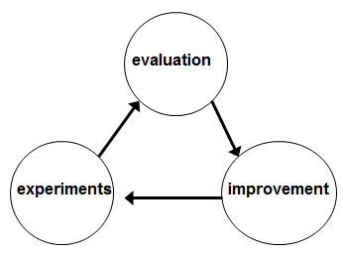
An effective performance evaluation system has standardized evaluation forms, performance measures, feedback guidelines and disciplinary procedures.

- What is the Cranfield evaluation system? Please describe the four parts of Cranfield evaluation system.
The Cranfield evaluation of IR systems is the result of early experimentation initiated by Cyril Cleverdon. Cleverdon started a series of projects, called the Cranfield projects, in 1957 that lasted for about 10 years in which he and his colleagues set the stage for information retrieval research.

- How to build corpus?
One such rule of thumb is the 15-15-15 rule, which basically implies that if you continue a monthly SIP of 15,000 rmb for 15 years, and the mutual fund scheme that you have opted for is able to generate annualized returns of 15%, then you shall be able to amass a corpus of 1 rmb crore at the end of 15 years.

- Please list Four types of Corpus.
- Static corpus
- Monitor corpus
- Multimedia corpus
- Specialized corpus
- Error-annotated corpus

- How to build Query sample set? Please describe it from three aspects,truth, typical and completeness.
Building Query sample:
Step 1: Add data sources.
Step 2: Join related data sources.
Step 3: Add output fields.
Step 4: Specify criteria.
Step 5: Summarize data.
Step 6: View the results.

A query is a question or a request for information expressed in a formal manner.

- How to build Standard answer set?
- Defining the problem.
- Planning the solution.
- Coding the program.
- Testing the program.
- Documenting the program.
Pooling method
-(semi-automatic and semi-manual)
- Please describe three types of information requirements including navigation,information and transcation requirements.
- Navigation - is either an RNP specification or an RNAV specification.
- Information - information be secured from unauthorized access, deletion, modification or disruption.
- Transaction - has 4 ascepts in it which are atomicity, consistency , Isolation and durability.
- Credibility - Specifications concerning the credibility of information such a list of trusted sources fro market data.
- Relevance - The relevance of information such as a requirement that an ecommerce search for men’s clothing not return any items classified as women’s or children’s clothing.
- Usability - for user interfaces for accessing information.

- Please give the evaluation method for each of information requirements except precision and recall.
- Process
- Impact
- Outcome
- summative evaluation

